MODULE- 3
POWER TRANSMISSION
Numerical Questions-
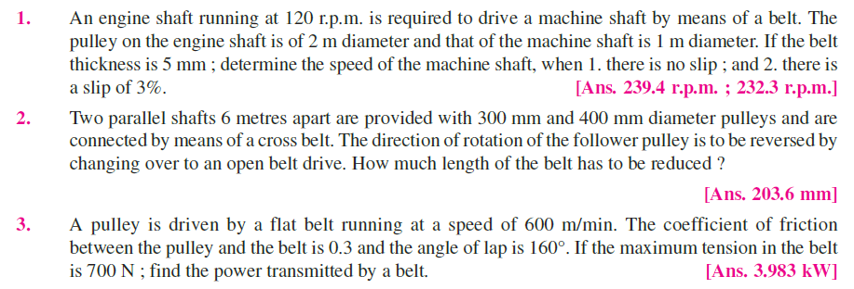
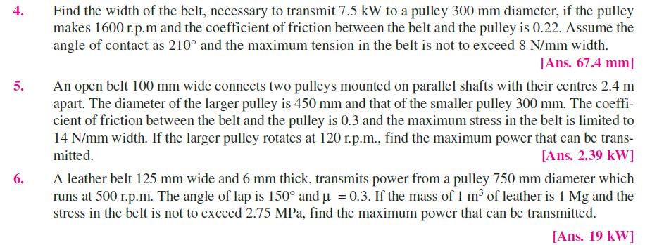
Long answer type-
-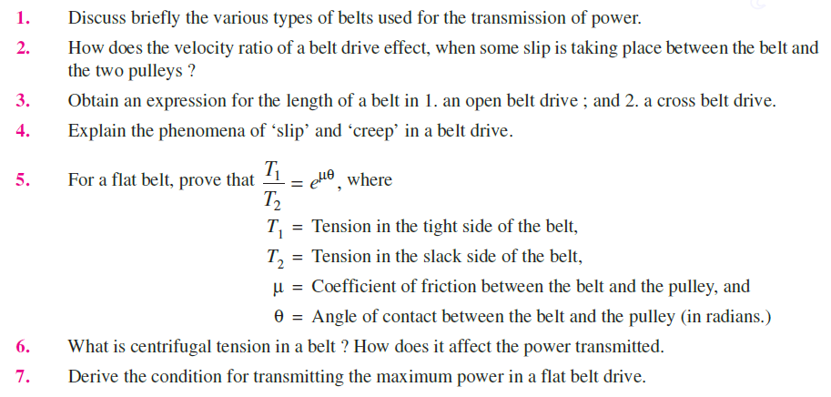

MODULE – 4
THEORY OF MACHINES
Numerical Based :

1. The length of the upper arm of a Watt governor is 400 mm and its inclination to the vertical is 30°. Find the percentage increase in speed, if the balls rise by 20 mm. [Ans. 3%]
- A Porter governor has two balls each of mass 3 kg and a central load of mass 15 kg. The arms are all 200 mm long, pivoted on the axis. If the maximum and minimum radii of rotation of the balls are 160 mm and 120 mm respectively, find the range of speed. [Ans. 28.3 r.p.m.]
- In a Porter governor, the mass of the central load is 18 kg and the mass of each ball is 2 kg. The top arms are 250 mm while the bottom arms are each 300 mm long. The friction of the sleeve is 14 N. If the top arms make 45° with the axis of rotation in the equilibrium position, find the range of speed of the governor in that position. [Ans. 15 r.p.m.]
- A loaded governor of the Porter type has equal arms and links each 250 mm long. The mass of each ball is 2 kg and the central mass is 12 kg. When the ball radius is 150 mm, the valve is fully open and when the radius is 185 mm, the valve is closed. Find the maximum speed and the range of speed. If the maximum speed is to be increased 20% by an addition of mass to the central load, find what additional mass is required. [Ans. 193 r.p.m. ; 16 r.p.m.; 6.14 kg]
- The arms of a Porter governor are 300 mm long. The upper arms are pivoted on the axis of rotation and the lower arms are attached to the sleeve at a distance of 35 mm from the axis of rotation. The load on the sleeve is 54 kg and the mass of each ball is 7 kg. Determine the equilibrium speed when the radius of the balls is 225 mm. What will be the range of speed for this position, if the frictional resistances to the motion of the sleeve are equivalent to a force of 30 N? [Ans. 174.3 r.p.m. ; 8.5 r.p.m.]
Long answer type:

1. What is the function of a governor ? How does it differ from that of a flywheel ?
2. State the different types of governors. What is the difference between centrifugal and inertia type governors ? Why is the former preferred to the latter ?
3. Explain the term height of the governor. Derive an expression for the height in the case of a Watt governor. What are the limitations of a Watt governor ?
4. What are the effects of friction and of adding a central weight to the sleeve of a Watt governor ?
5. Discuss the controlling force and stability of a governor and show that the stability of a governor depends on the slope of the curve connecting the controlling force (FC) and radius of rotation (r) and the value (FC /r).
6. What is stability of a governor ? Sketch the controlling force versus radius diagrams for a stable,
unstable and isochronous governor. Derive the conditions for stability.
7. Explain clearly how would you determine from the controlling force curve whether a governor is stable, unstable or isochronous. Show also how the effect of friction may be indicated on the curve.
8. Define and explain the following terms relating to governors :
1. Stability, 2. Sensitiveness, 3. Isochronism,

MODULE – 5
THEORY OF MACHINES
- Why is balancing of rotating parts necessary for high speed engines ?
- Explain clearly the terms ‘static balancing’ and ‘dynamic balancing’. State the necessary conditions to achieve them.
- Explain the method of balancing of different masses revolving in the same plane.
- Discuss how a single revolving mass is balanced by two masses revolving in different planes.
- How the different masses rotating in different planes are balanced ?
- Four masses A, B, C and D revolve at equal radii and are equally spaced along a shaft. The mass B is 7 kg and the radii of C and D make angles of 90° and 240° respectively with the radius of B. Find the magnitude of the masses A, C and D and the angular position of A so that the system may be completely balanced. [Ans. 5 kg ; 6 kg ; 4.67 kg ; 205° from mass B in anticlockwise direction]
- Four masses A, B, C and D are attached to a shaft and revolve in the same plane. The masses are 12 kg, 10 kg, 18 kg and 15 kg respectively and their radii of rotations are 40 mm, 50 mm, 60 mm and 30 mm. The angular position of the masses B, C and D are 60°, 135° and 270° from the mass A. Find the magnitude and position of the balancing mass at a radius of 100 mm. [Ans. 7.56 kg ; 87° clockwise from A]
- Explain the Balancing of Reciprocating parts?
- What are the principles of Balancing of Reciprocating parts?
- A, B, C and D are four masses carried by a rotating shaft at radii 100 mm, 150 mm, 150 mm and 200 mm respectively. The planes in which the masses rotate are spaced at 500 mm apart and the magnitude of the masses B, C and D are 9 kg, 5 kg and 4 kg respectively. Find the required mass A and the relative angular settings of the four masses so that the shaft shall be in complete balance.[Ans. 10 kg ; Between B and A 165°, Between B and C 295°, Between B and D 145°]

MODULE – 6
THEORY OF MACHINES
1.What are the causes and effects of vibrations ?
2. Define, in short, free vibrations, forced vibrations and damped vibrations.
3. Discuss briefly with neat sketches the longitudinal, transverse and torsional free vibrations.
4. Derive an expression for the natural frequency of free transverse and longitudinal vibrations by
equilibrium method.
5. Discuss the effect of inertia of the shaft in longitudinal and transverse vibrations.
6. Deduce an expression for the natural frequency of free transverse vibrations for a simply supported
shaft carrying uniformly distributed mass of m kg per unit length.
7. Deduce an expression for the natural frequency of free transverse vibrations for a beam fixed at
both ends and carrying a uniformly distributed mass of m kg per unit length.
8. Establish an expression for the natural frequency of free transverse vibrations for a simply supported
beam carrying a number of point loads, by (a) Energy method ; and (b) Dun Kerley’s method.
9. Explain the term ‘whirling speed’ or ‘critical speed’ of a shaft. Prove that the whirling speed for a rotating shaft is the same as the frequency of natural transverse vibration.

NUMERICAL BASED:
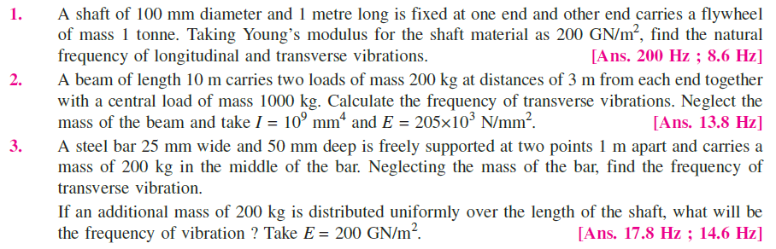

REFERENCE BOOKS:
- R.S Khurmi
- S.S Ratan

